Sprint 1 - Endurance Design Document

November 12, 2020

Table of Contents
1. Executive Summary 3
1.1 Project Overview 3
1.2 Purpose and Scope of this Specification 3
2. Product/Service Description 3
2.1 Product Context 3
2.2 User Characteristics 3
2.3 Assumptions 4
2.4 Constraints 4
2.5 Dependencies 4
3. Requirements 4
3.1 Functional Requirements 4
3.2 Security 5
3.2.1 Protection 5
3.2.2 Authorization and Authentication 5
3.3 Portability 5
4. Requirements Confirmation/Stakeholder sign-off 5
5. System Design 6
5.1 Algorithm 6
5.2 System Flow 6
5.3 Software 8
5.4 Hardware 10
5.5 Test Plan 10
5.6 Task List/Gantt Chart 12
5.7 Staffing Plan 12

Executive Summary

Project Overview
This system design document encapsulates the first part of the three-part robotics project in CS-104: endurance. The goal of the robotics project is to design and document three separate sprints that focus on endurance, accuracy, and speed. This project, referred to as Sprint 1 - Endurance, focuses on the robot’s ability to complete an endurance course. The endurance sprint requires that a Sphero robot circumnavigates the rectangular periphery of a room and that the robot indicates the program’s start and end with sound and lights. This project’s intended audience is Professor Eckert, all CS-104 sections, any faculty member or student part of the Monmouth University Computer Science and Software Engineering Department, and anyone with or without experience with an interest in coding and developing software and algorithms.

Purpose and Scope of this Specification
The purpose of this project is to design the software necessary for the robot to complete the endurance course. In this sprint, the Sphero robot must demonstrate its ability to circumnavigate the rectangular periphery of a room. This project’s intended audience is Professor Eckert, all CS-104 sections, any faculty member or student part of the Monmouth University Computer Science and Software Engineering Department, and anyone with or without experience with an interest in coding and developing software and algorithms.
In Scope
This document addresses requirements related to Phase 1 of the robot project:
- modification and execution of Sphero Edu code to meet the mandates of Sprint 1 – Endurance
Out of Scope
The following items in Phases 2 and 3 of the Robotics Project are out of scope:
- modification and execution of Sphero Edu code to meet the mandates of Sprint 2 – Accuracy (Phase 2)
- modification and execution of Sphero Edu code to meet the mandates of Sprint 3 – Agility (Phase 3)

Product/Service Description
The general factor affecting this product and its requirements is the ability of the robot to successfully pass the endurance test. The robot must fulfill the requirements that the endurance test calls for.

Product Context
In the context of other robotics products, this product is revolutionary because of its ease of use, simplistic, straightforward code, and extensive compatibility with almost any personal device. This product relates to this team’s two other products in that it is one of three phases of the robotics project. It will be presented in the culmination of all three sprints called the robotics triathlon. This product is independent and self-contained; it is completed separately under a different schedule and plan than the other two sprints. This product is interfaced with a Sphero SPRK+ robot that runs the code behind this project. This product must pass the endurance test.

User Characteristics
- Students/faculty/staff/other with or without experience with an interest in coding and developing software and algorithms
- New and experienced programmers who are interested in using unique frameworks such as the Sphero Edu platform. Sphero understands block code as well as JavaScript, so it is welcoming and provides options to new and experienced programmers.

Assumptions
It is assumed that:
- User has access to a Sphero SPRK+ robot as well as its required accessories: carrying case, charger block, charging cable, charging cradle, and silicone cover
- User has access to a Sphero-supported operating system/device
- Bluetooth capability of the parent device to facilitate a connection with the Sphero robot
- User knows how to operate and navigate the Sphero Edu application
- User has access to a Wi-Fi connection

Constraints
- Project deadline: Thursday, November 12, 2020 at 11:30a.m.
- Team members’ schedules and availability
- Access to the Monmouth University campus is limited due to COVID-19 safety restrictions
  - The team decided that it is best to stay safe and complete this project off-campus
- The original endurance course layout in Howard Hall (HH) 208 has a rectangular periphery with the dimensions of 22 feet by 11 feet. Due to the team’s inability to develop and test the software on-campus as well as the team’s space restrictions, the dimensions of the course had to be decreased to 11 feet by 5 feet. The software still performs per the requirements.
- User must be in close proximity to the robot to maintain the Bluetooth connection; program will cease if user goes out of Bluetooth range

Dependencies
- Access to a Sphero SPRK+ robot
- Access to an up-to-date version of the Sphero Edu application on a phone, tablet, or computer
- Access to the latest version of the code for this project
- Access to a Wi-Fi network and a Bluetooth-enabled device to connect to the robot
- Access to an area with the dimensions of at least 11 feet by 5 feet

Requirements

Functional Requirements
Req# | Requirement | Comments | Priority | Date Rvwd | SME Reviewed / Approved
ENDUR_01 | Robot program must start while on the starting yellow tile | Necessary to cover the correct distance and reach the center of each tile | 1 | 11/10/20 | Joseph F.  Justyce G.  Shane H.
ENDUR_02 | Robot must start with a green LED light | Indicates that the program is initialized and about to begin | 1 | 11/10/20 | Joseph F.  Justyce G.  Shane H.
ENDUR_03 | Robot must speak “Ready, set, go!” prior to moving forward | Indicates readiness to perform the program | 1 | 11/10/20 | Joseph F.  Justyce G.  Shane H.
ENDUR_04 | Robot moves forward to the 1st yellow tile and turns 90 degrees | Travels the width side of the rectangle (11 feet) | 1 | 11/10/20 | Joseph F.  Justyce G.  Shane H.
ENDUR_05 | Robot moves forward to the 2nd yellow tile and turns another 90 degrees | Travels the length side of the rectangle (5 feet) | 1 | 11/10/20 | Joseph F.  Justyce G.  Shane H.
ENDUR_06 | Robot moves to the 3rd yellow tile and turns another 90 degrees | Travels the width side of the rectangle (11 feet) | 1 | 11/10/20 | Joseph F.  Justyce G.  Shane H.
ENDUR_07 | Robot moves forward to the 4th yellow tile and stops | Travels the length side of the rectangle (5 feet) | 1 | 11/10/20 | Joseph F.  Justyce G.  Shane H.
ENDUR_08 | Robot must end the sprint with a red LED light | Indicates that the robot has ended at the starting point | 1 | 11/10/20 | Joseph F.  Justyce G.  Shane H.
ENDUR_09 | Robot must speak “I’m done, and I need water,” upon completion of the program | Indicates program completion and end of circumnavigation | 1 | 11/10/20 | Joseph F.  Justyce G.  Shane H.

Security

Protection
- Individual accounts on the Sphero Edu and GitHub platforms are associated with a personal email and secure password; log-in information is processed and encrypted through HTTPS for security
- Access to edit the code and contribute to this project is limited to group members via account-specific sharing on Sphero Edu and GitHub
- Sensor data is stored locally
- The Sphero robot is signed out through the Monmouth University Computer Science and Software Engineering Department and is only available for use by the team it is assigned to
- The Sphero robot has a carrying case to protect and safely store it
- The Sphero robot has a silicone cover to protect it from scratches and increase grip

Authorization and Authentication
- Individual accounts on the Sphero Edu platform associated with an e-mail address and password allow access to create and share code
- Individual accounts on GitHub associated with an e-mail address and password to collaborate and share code with team members through a collaboration branch

Portability
- The Sphero Edu block code relevant to this project is portable to supported devices and operating systems because it can be accessed seamlessly through the Sphero Edu platform or GitHub
- A copy of the Sphero Edu block code is available in this document as well as this project’s public GitHub repository, thus the code can be replicated by anyone
- The Sphero SPRK+ robot that executes code is portable due to its small form-factor and can run this software in an 11-foot by 5-foot rectangular area

Requirements Confirmation/Stakeholder sign-off

Meeting Date | Attendees (name and role) | Comments
11/10/20 | Joseph Furmanowski (Project Manager)  Justyce Graham (Programmer)  Shane Hannigan (Programmer) | Confirmed ENDUR_01 through ENDUR_09

System Design

Algorithm
- Start program when robot is on the starting yellow tile
- Robot outputs green main LED to start
- Robot says “Ready, set, go!”
- Robot rolls forward 11 feet at 40 speed at 0 degrees for 9 seconds
- Robot stops at first yellow tile
- Robot rolls forward 5 feet at 40 speed at 90 degrees for 4.25 seconds
- Robot stops at second yellow tile
- Robot rolls forward 11 feet at 40 speed at 180 degrees for 9 seconds
- Robot stops at third yellow tile
- Robot rolls forward 5 feet at 40 speed at 270 degrees for 4.25 seconds
- Robot stops at fourth yellow tile where it started
- Robot outputs red main LED
- Robot says “I’m done, and I need water.”
- End the program

System Flow
- See next page for system flow chart
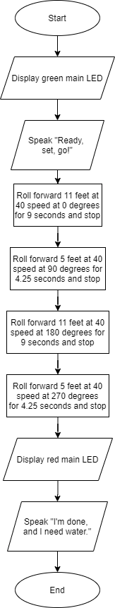

Software
- Sphero Edu App
  - Allows for the creation, development, sharing, and updating of code for the robot
- Block coding
  - Simple commands that the robot follows
  - Block coding is an abstraction of the JavaScript language that is behind the blocks
- GitHub
  - Facilitates collaboration and updates from all team members
- Sphero block code
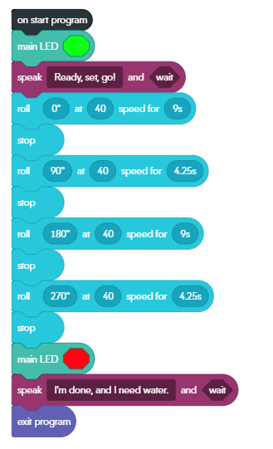
- Sensor data
  - See next pages for robot sensor data
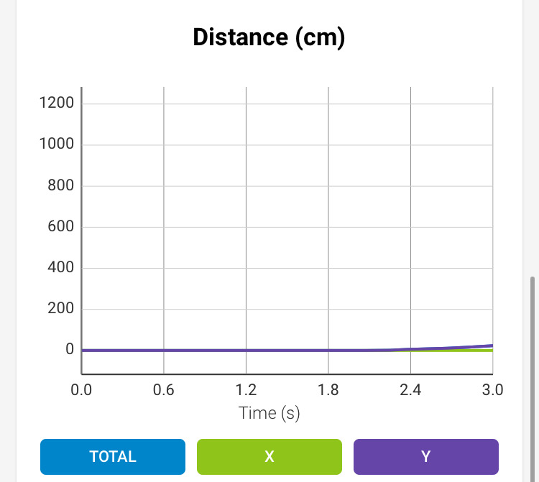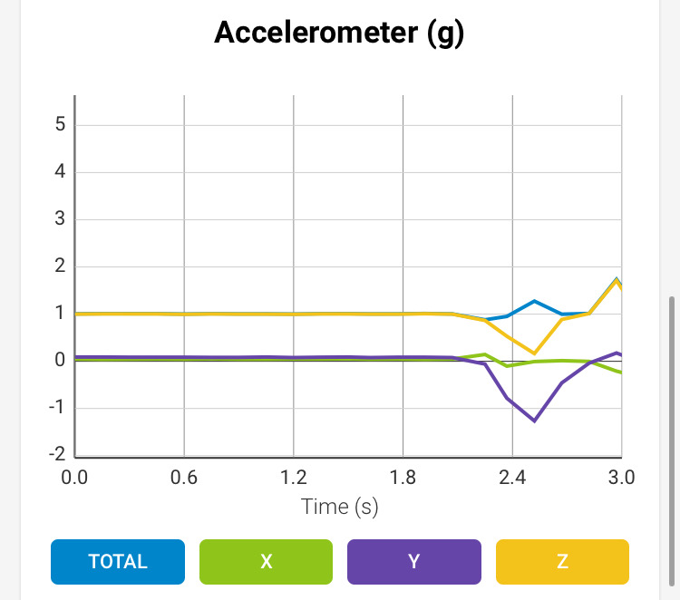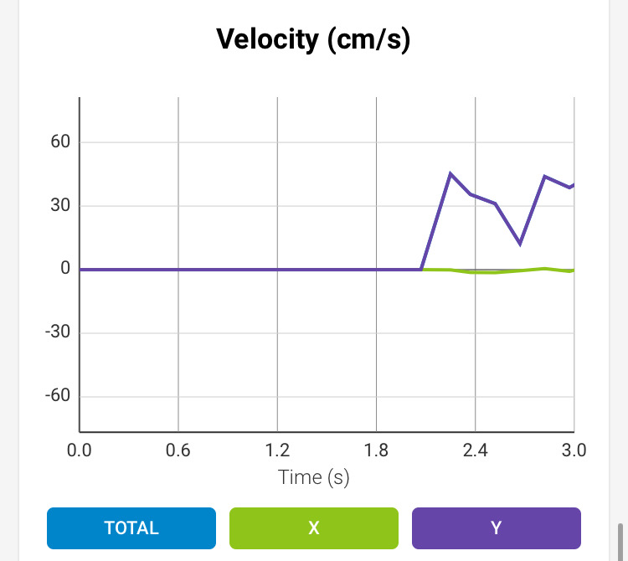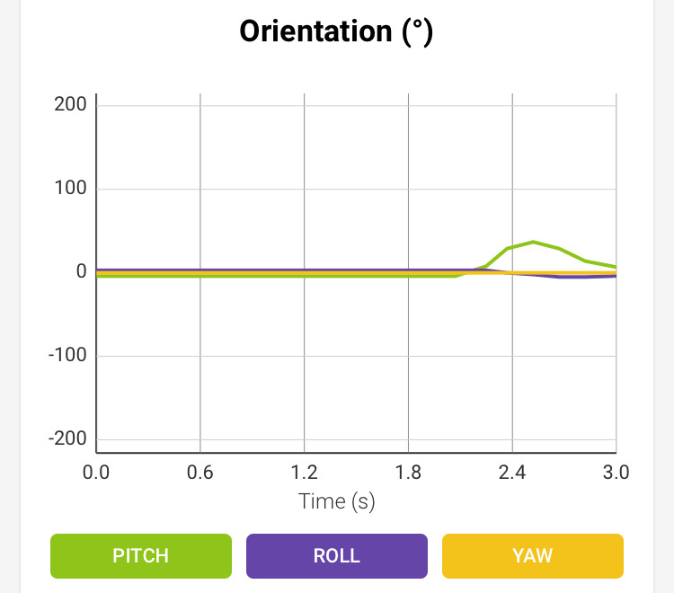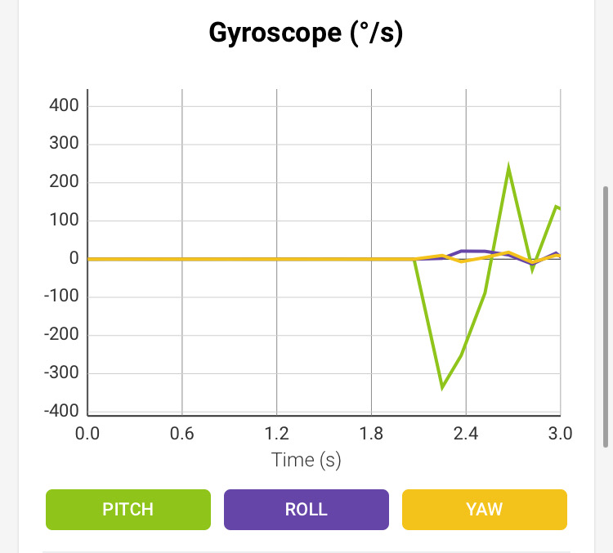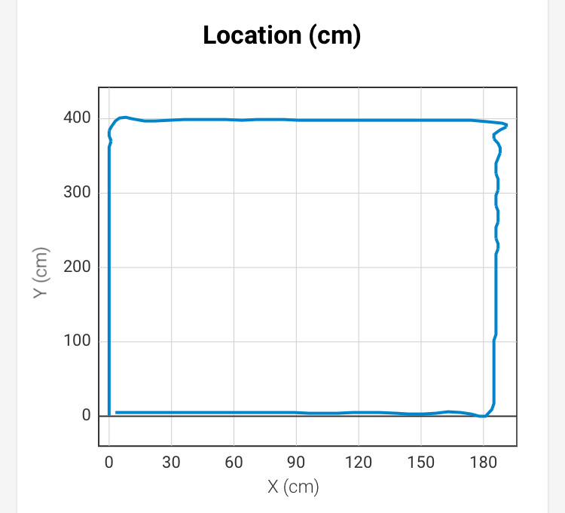

Hardware
- Personal computers running Microsoft Windows 10 and Mac OS developed the application
- An Apple iPhone 6s running iOS 13.3.1 connected to Sphero via Bluetooth tested the application
- A Sphero SPRK+ robot (SK-36FC) borrowed from the Monmouth University Computer Science and Software Engineering Department demonstrated and performed the program

Test Plan

Reason for Test Case | Test Date | Expected Output | Observed Output | Staff Name | Pass/Fail
Robot starts with green LED and says, “Ready, set, go!” | 11/10/20 | Robot starts with green LED and says, “Ready, set, go!” | Robot started with green LED and said, “Ready, set, go!” | Joseph F. | Pass
Rolls 0°, moves forward 11 feet to 1st yellow tile | 11/10/20 | Rolls 0°, moves forward 11 feet to the 1st yellow tile | Rolled 0°, but robot went too far past the 1st yellow tile | Joseph F. | Fail
Moves forward 11 feet to 1st yellow tile after adjusting roll time | 11/10/20 | Rolls 0°, moves forward 11 feet to the 1st yellow tile | Rolled 0°, and robot moved forward 11 feet to the 1st yellow tile | Joseph F. | Pass
Rolls 90°, moves forward 5 feet to the 2nd yellow tile | 11/10/20 | Rolls 90°, moves forward 5 feet to the 2nd yellow tile | Rolled 90°, but robot went too far past the 2nd yellow tile | Joseph F. | Fail
Rolls 90°, moves forward 5 feet to the 2nd yellow tile after adjusting roll time | 11/10/20 | Rolls 90°, moves forward 5 feet to the 2nd yellow tile | Rolled 90°, and robot moved forward 5 feet to the 2nd yellow tile | Joseph F. | Pass
Rolls 180°, moves forward 11 feet to the 3rd yellow tile | 11/10/20 | Rolls 180°, moves forward 11 feet to the 3rd yellow tile | Rolled 180°, but robot went too far past the 3rd yellow tile | Joseph F. | Fail
Rolls 180°, moves forward 11 feet to the 3rd yellow tile after adjusting roll time | 11/10/20 | Rolls 180°, moves forward 11 feet to the 3rd yellow tile | Rolled 180°, and robot moved forward 11 feet to the 3rd yellow tile | Joseph F. | Pass
Ends where it started; rolls 270°, moves forward 5 feet to the 4th yellow tile/starting point | 11/10/20 | Ends where it started; rolls 270°, moves forward 5 feet to the 4th yellow tile/starting point | Did not end where it started; rolled 270°, but robot went too far past the 4th yellow tile/starting point | Joseph F. | Fail
Ends where it started; rolls 270°, moves forward 5 feet to the 4th yellow tile/starting point after adjusting roll time | 11/10/20 | Ends where it started; rolls 270°, moves forward 5 feet to the 4th yellow tile/starting point | Ended where it started; rolled 270°, and robot moved forward 5 feet to the 4th yellow tile/starting point | Joseph F. | Pass
Robot ends with red LED and says, “I’m done, and I need water.” | 11/10/20 | Robot ends with red LED and says, “I’m done, and I need water.” | Robot ended with red LED and said, “I’m done, and I need water.” | Joseph F. | Pass

Task List/Gantt Chart
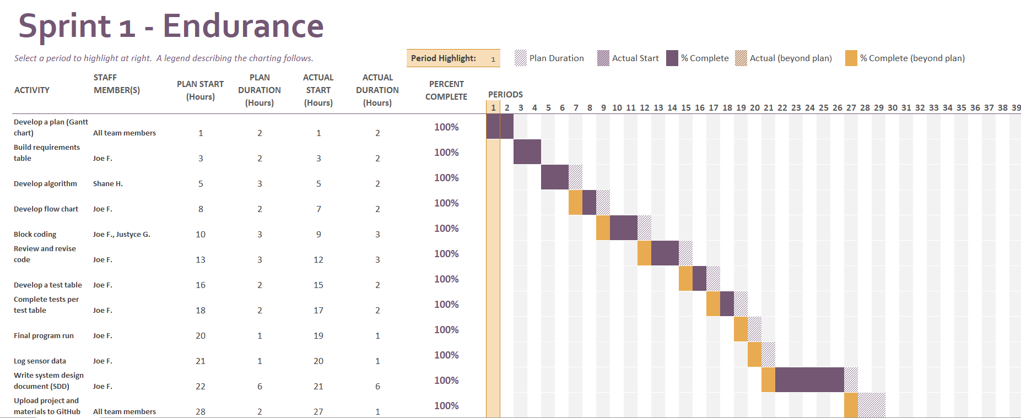

Staffing Plan

Name | Role | Responsibility | Reports To
Joseph Furmanowski | Project Manager,  Programmer | - Oversee project and maintain quality control  - Develop a plan  - Build requirements table  - Develop flow chart  - Write code  - Execute, test, and revise code and algorithm  - Log sensor data  - Write SDD  - Collaborate via GitHub | - Professor Eckert
Justyce Graham | Programmer,  Task Planner | - Develop a plan  - Finalize the Gantt chart and verify that it suits the project  - Write code  - Collaborate via GitHub | - Professor Eckert  - Project Manager
Shane Hannigan | Programmer,  Algorithm Designer | - Develop a plan  - Design algorithm  - Write code  - Collaborate via GitHub | - Professor Eckert  - Project Manager

